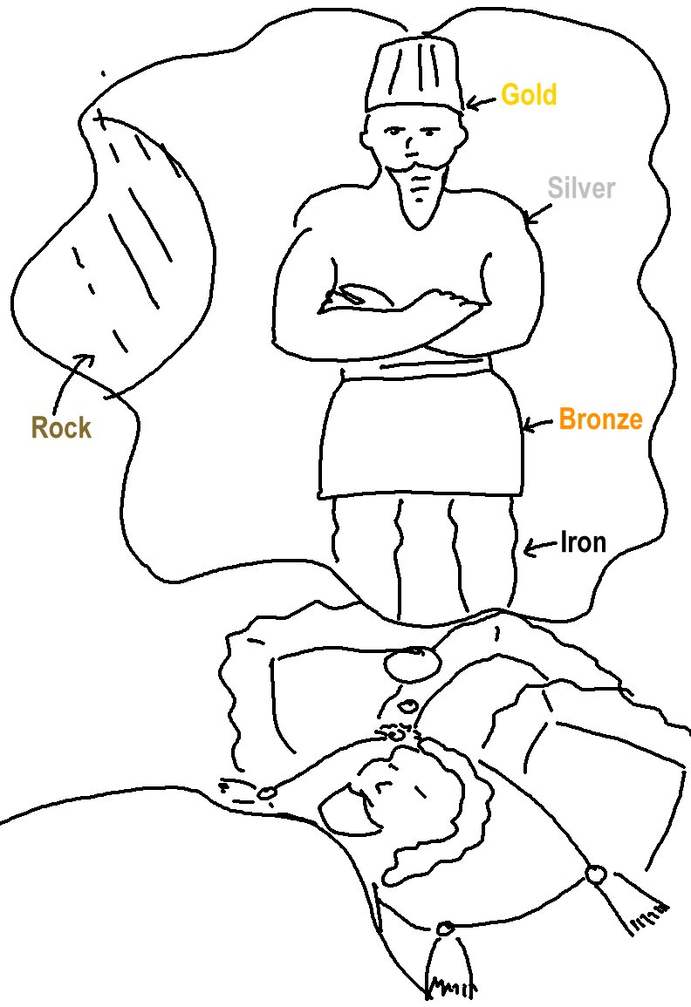

Whatever the Lord God _ _ _ _ _ to do, He _ _ _ _ _ his servants, the prophets.
Amos 3:7_{CEV}

